**Closure of the Hastings Campus**

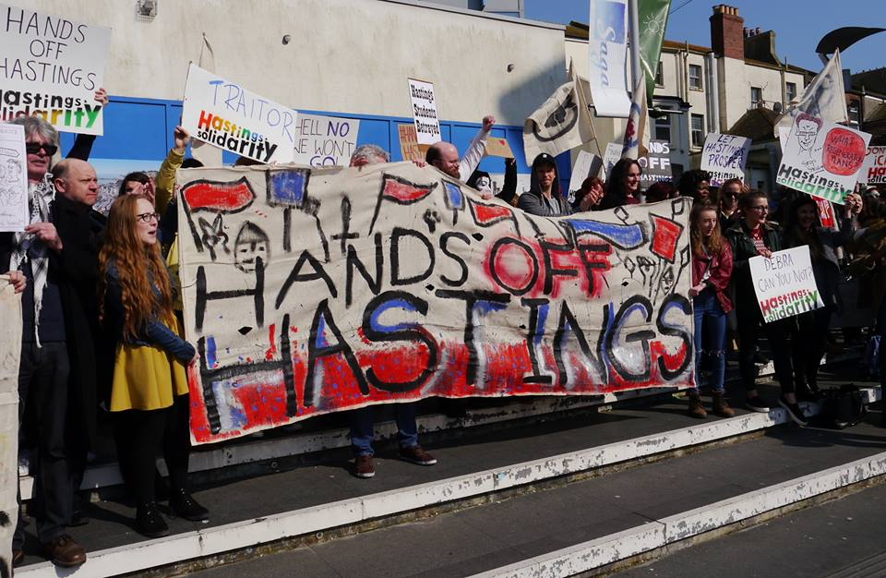

**What does this mean for the town?**

• Unemployment

• Loss of income for businesses and developers

• Reduced investment halting regeneration

• Potentially more empty buildings in the town centre

• Loss of a diverse community of academics, educators and graduates

• *Vastly* reduced HE provision at a ‘new University Centre’ in partnership with Sussex Coast College.

**The battle for jobs and public services**

**Join the demo Saturday 14th May** @ 12pm, Priory Square University Building

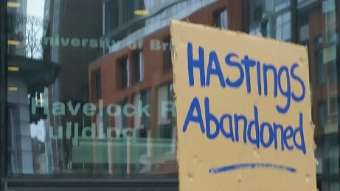

**What does the campus offer?**

• Provides meaningful employment in the town

• A key role in the town’s ongoing regeneration

• Developing local community partnerships through Economic and Social Engagement

• Widening participation to increase aspiration and access to Higher Education

• A range of courses attracting students locally, nationally and internationally

• Smaller class sizes enabling greater participation and access to modern resources and facilities and outstanding support

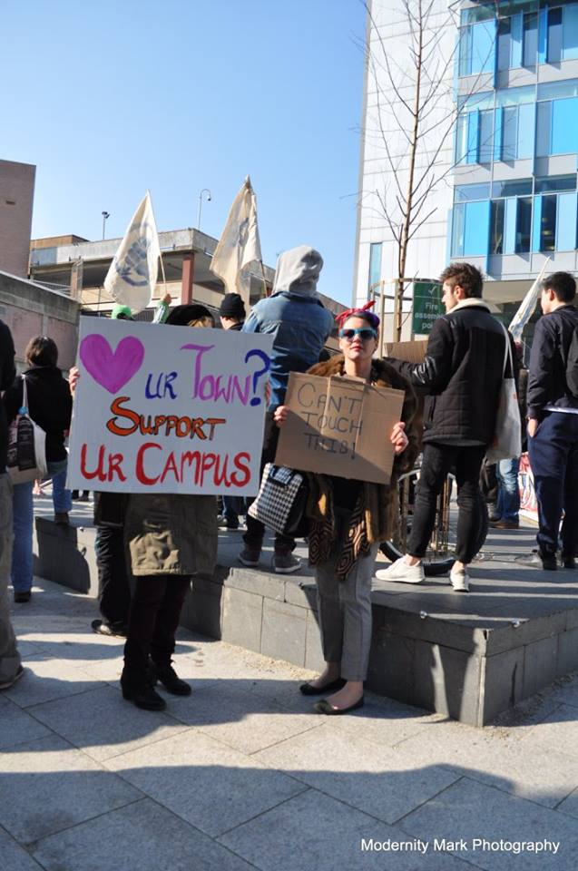

**Support the campaign**

**Facebook:** Hastings Campus Solidarity

**Twitter:** #HandsOffHastings

**Sign the petition:** https://www.change.org/p/save-hastings-campus