University of Brighton Anti-Racist Toolkit
Racism is a very complex social construct and often hard to define and talk about. As such, I fully appreciate that individuals may be at different levels of their racial literacy journey and how it manifests in society and the workplace, or how to even deal with it when it raises its ugly head!
I wanted to develop an easy-to-digest toolkit, and a starting point, for anyone to use to offer support with their racial literacy learning and to help find out what it means to be ‘anti-racist’, as well as becoming allies to support their minority ethnic colleagues and community.
The Anti-Racist Toolkit has been developed using the learning platform Padlet and is to be used as a learning aid. It is by no means a full exhaustive list of resources and publications on this subject matter but will be regularly updated. As the lived experiences of minority ethnic people will be unique and differ from each other the Anti-Racist Toolkit is a good starting point to find out about these complexities, issues, and challenges. It can also be used as a reference point for colleagues to share information of their own as they engage with its contents.
By: Bill Acharjee, South-East Black Members Officer
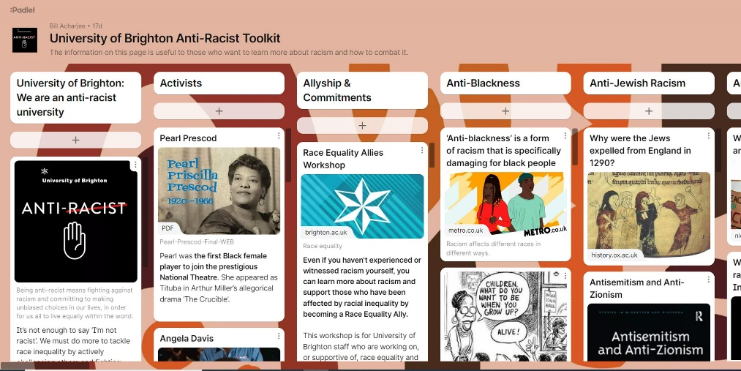
Link: https://universityofbrighton.padlet.org/Brighton_Anti_Racist_Toolkit/3ulm39d4w29dx6sw

